Problem 1: Packet switching and delay (30 points)

In modern packet-switched networks, including the Internet, the source host segments long, application-layer messages (for example, an image or a music file) into smaller packets and sends the packets into the network. The receiver then reassembles the packets back into the original message. We refer to this process as **message segmentation**. Fig. 1 illustrates the end-to-end transport of a message with and without message segmentation. Consider a message that is 106 bits long that is to be sent from source to destination in Figure 1. Suppose each link in the figure is 5 Mbps. Ignore propagation, queuing, and processing delays.

1. Consider sending the message from source to destination without message segmentation. How long does it take to move the message from the source host to the first packet switch? Keeping in mind that each switch uses store-and-forward packet switching, what is the total time to move the message from source host to destination host?
2. Now suppose that the message is segmented into 100 packets, with each packet being 10,000 bits long. How long does it take to move the first packet from source host to the first switch? When the first packet is being sent from the first switch to the second switch, the second packet is being sent from the source host to the first switch. At what time will the second packet be fully received at the first switch?
3. How long does it take to move the file from source host to destination host when message segmentation is used? Compare this result with your answer in part (1) and comment.

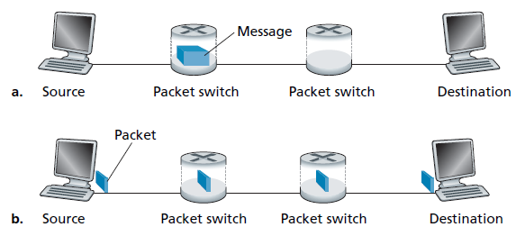

Fig.1. End to end message transport:

a) without message segmentation b) with message segmentation

Problem 2: HTTP1.1 (20 points)

Suppose within your Web browser you click on a link to obtain a Web page. The IP address for the associated URL is not cached in your local host, so a DNS lookup is necessary to obtain the IP address. Suppose that n DNS servers are visited before your host receives the IP address from DNS; the successive visits incur an RTT of RTT1, . . . , RTTn. Further suppose that the Web page associated with the link contains exactly one object, consisting of a small amount of HTML text. Let RTT0 denote the RTT between the local host and the server containing the object.

1. Assuming zero transmission time of the object, how much time elapses from when the client clicks on the link until the client receives the object?
2. Suppose the HTML file references eight very small objects on the same server. Neglecting transmission times, how much time elapses with
3. Non-persistent HTTP with no parallel TCP connections?
4. Non-persistent HTTP with the browser configured for 6 parallel connections?
5. Persistent HTTP?

Problem 3: HTTP/2 (20 points)

Consider sending over HTTP/2 a Web page that consists of one video clip, and five images. Suppose that the video clip is transported as 2000 frames, and each image has three frames.

1. If all the video frames are sent first without interleaving, how many “frame times” are needed until all five images are sent?
2. If frames are interleaved, how many frame times are needed until all five images are sent.

Problem 4: Web Cache (20 points)

Consider Figure 2, for which there is an institutional network connected to the Internet. Suppose that the average object size is 850,000 bits and that the average request rate from the institution’s browsers to the origin servers is 16 requests per second. Also suppose that the amount of time it takes from when the router on the Internet side of the access link forwards an HTTP request until it receives the response is 3 seconds on average. Model the total average response time as the sum of the average access delay (that is, the delay from Internet router to institution router) and the average Internet delay. For the average access delay, use **a/(1 -ab)**, where **a** is the average time required to send an object over the access link and **b** is the arrival rate of objects to the access link.

1. Find the total average response time.
2. Now suppose a cache is installed in the institutional LAN. Suppose the miss rate is 0.4. Find the total response time.

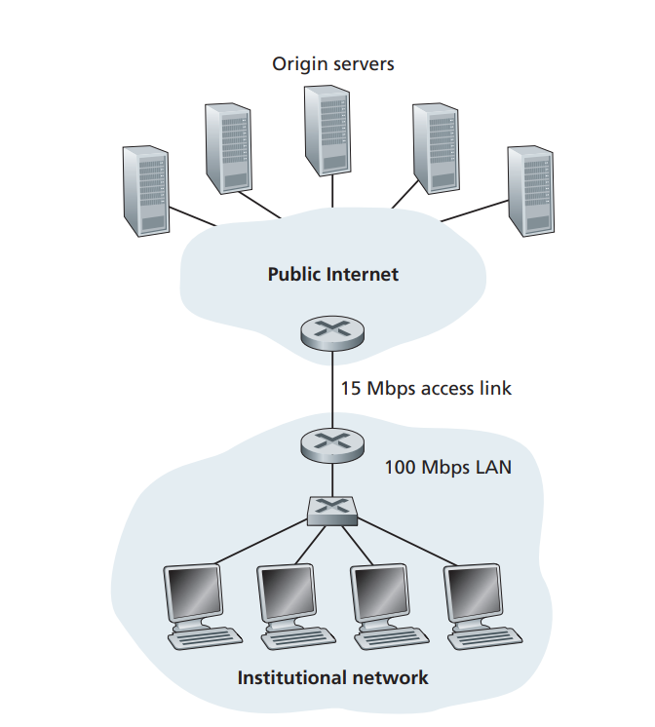

Figure.2 Adding a cache to the institutional network

Problem 5: P2P (10 points)

Suppose Bob joins a BitTorrent torrent, but he does not want to upload any data to any other peers (so called free-riding).

1. Bob claims that he can receive a complete copy of the file that is shared by the swarm (the torrent). Is Bob’s claim possible? Why or why not?
2. Bob further claims that he can further make his “free-riding” more efficient by using a collection of multiple computers (with distinct IP addresses) in the computer lab in his department. How can he do that?